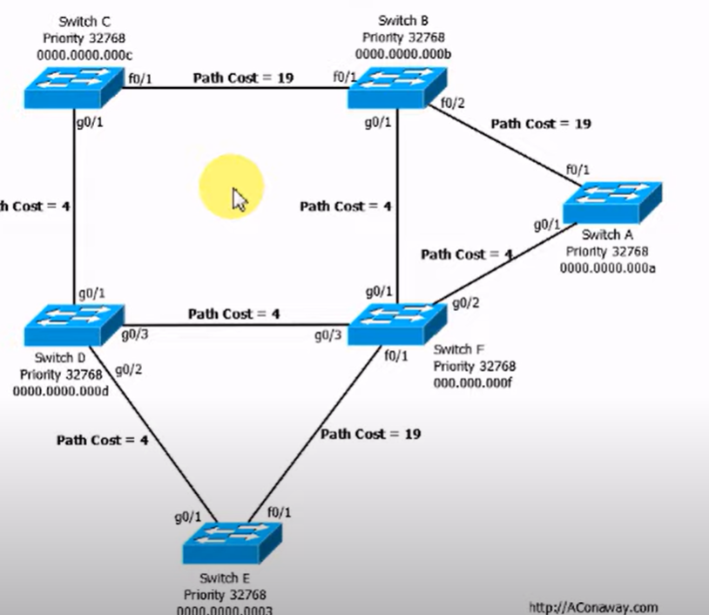

Note: Fast Ethernet F0 = cost of 19 for that path

Gig Eth G0 = 4 per path see above

[STP Exercise #1 Solution (youtube.com)](https://www.youtube.com/watch?v=y-SppCHx1Qs)

[CCNA 200-125 Exam: STP Questions With Answers - Config Router](https://www.configrouter.com/ccna-exam-stp-7027/)

<https://learnnetworkingwithme.files.wordpress.com/2012/07/stp-exercises-1-21.pdf>

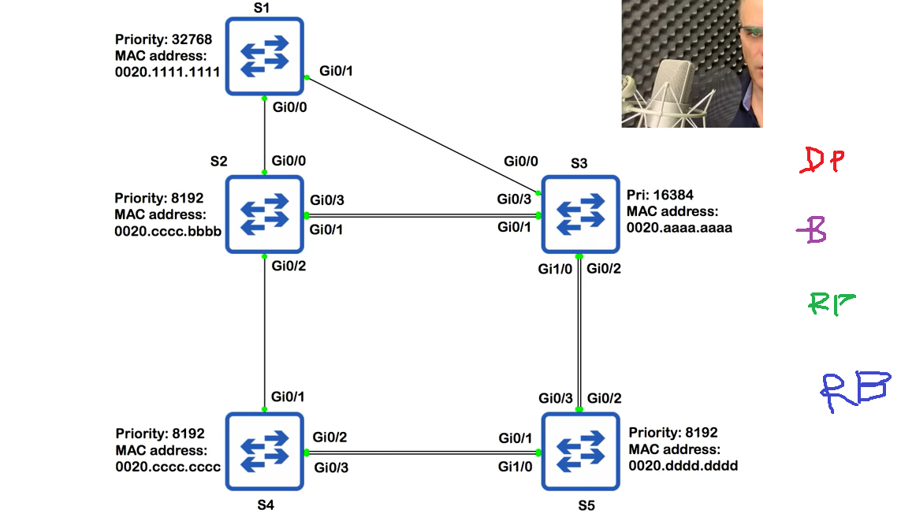

Answer:

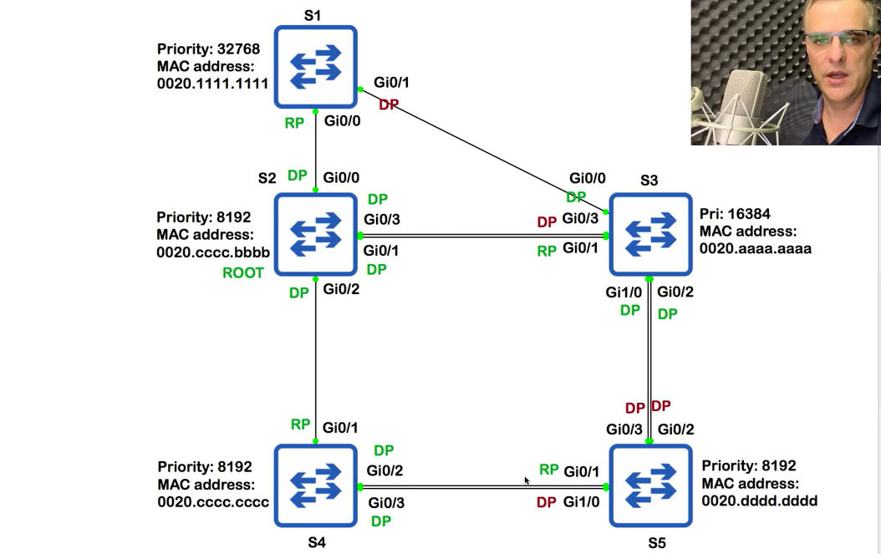

Process:

1. Find the path costs… Giga Eth is 4, Fast Eth is 19

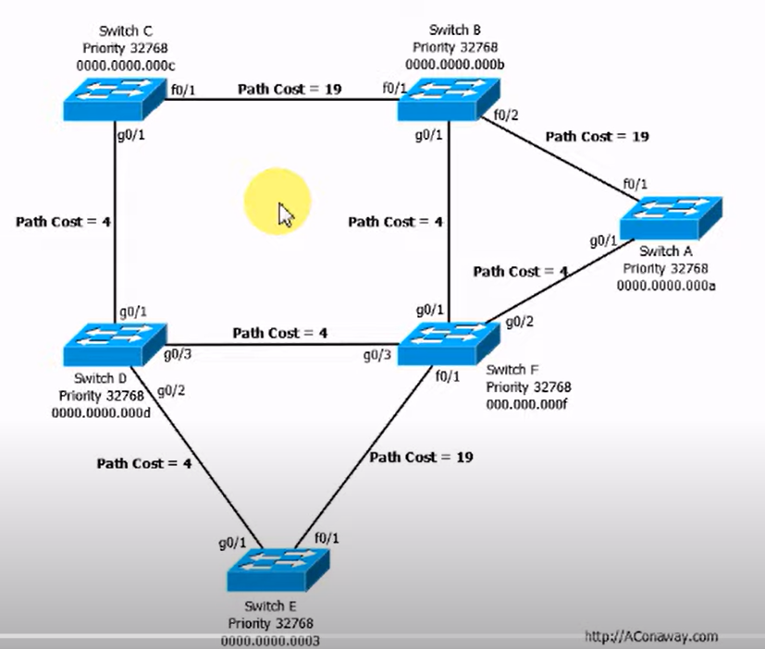

1. Find ROOT BRIDGE:

This is the lowest priority switch

If all priorities are the same, look at MAC address… lowest letter is A… numbers come lower than letters

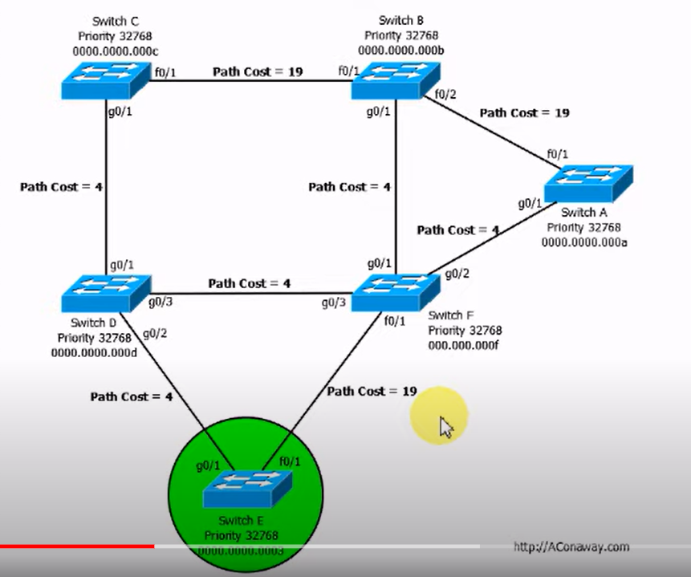

1. Find the ROOT PORTS of the switches

This is a port on a switch with LOWEST PATH COST to ROOT BRIDGE

Compare paths from a switch to root bridge… generally shortest has LEAST COST unless interface speeds change…

Fast eth paths have a massive cost… gig e is low

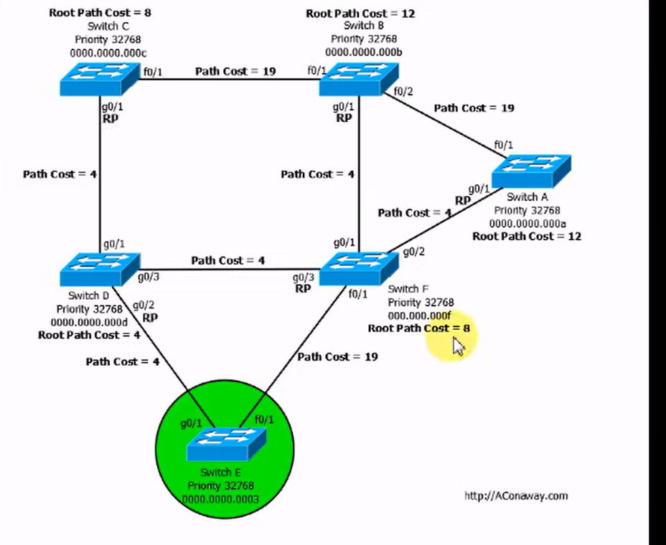

1. DESIGNATED PORTS cannot be ROOT PORTS

All ports on ROOT BRIDGE are always DESIGNATED AS THEIR COST IS 0, LOW

Any switches with 1 FREE PORT LEFT…HAS TO BE DESIGNATED PORT

IF path between two free ports that can both be designated… go to…

Spanning Tree tie-breakers:

1. Root bridge ID… lowest is designated port…if same go to 2
2. Root path cost… lower means it is designated port… if same go to 3
3. Bridge ID… lowest is designated port

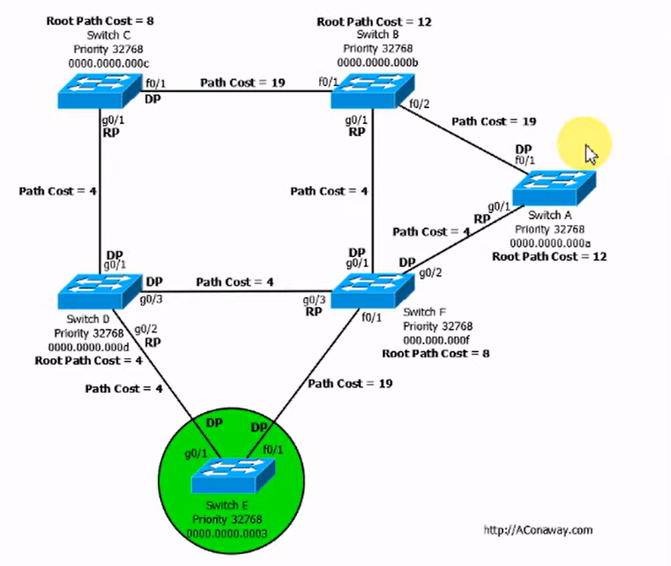

5. BLOCK PORTS

Go wherever ports are NOT LABELLED

These will get rid of loops through SPT… check where these blocks are…do they block potential loops? THEY SHOULD

